PRACTICAL NO. 3

Message Authentication Codes: Implement algorithms to generate and verify message authentication codes (MACs) for ensuring data integrity and authenticity.
- MD5
Code:
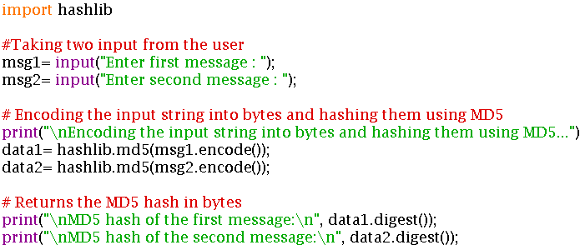
Output:
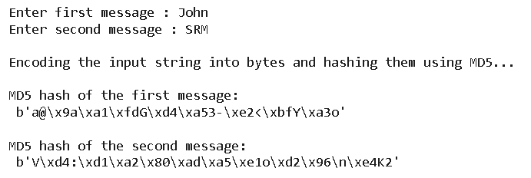

- SHA1
Code:
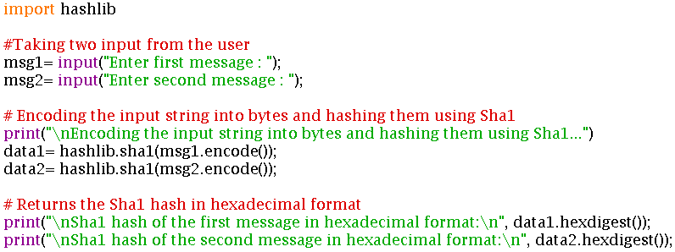
Output:
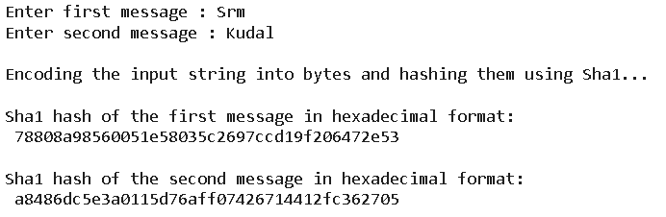

- File handling
input.txt file:
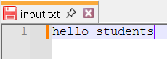
Code:
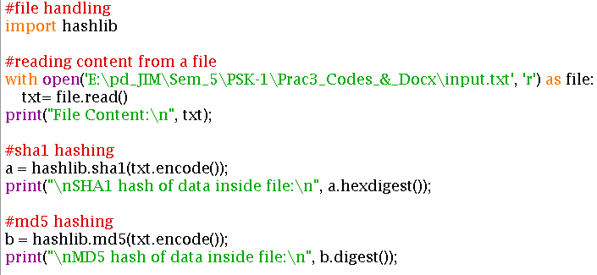
Output:
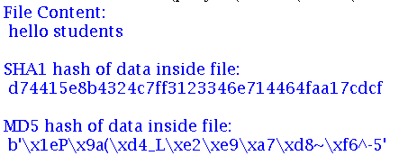

- Verify MAC
Code:
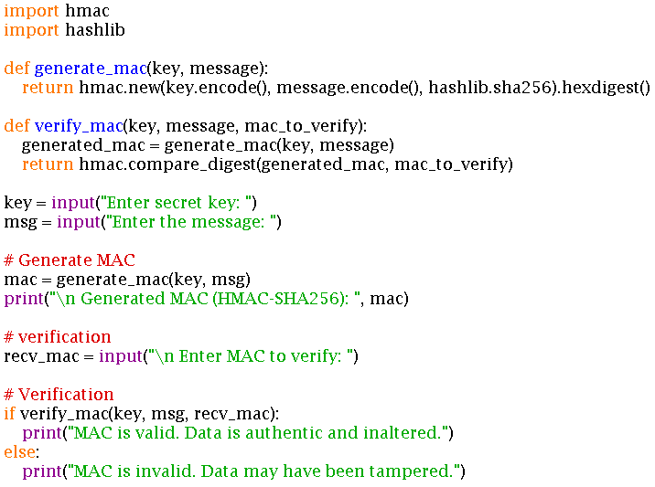

Output:
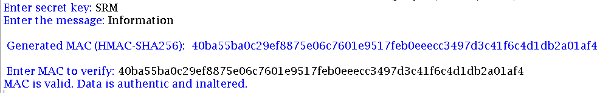

- Choice
Code:
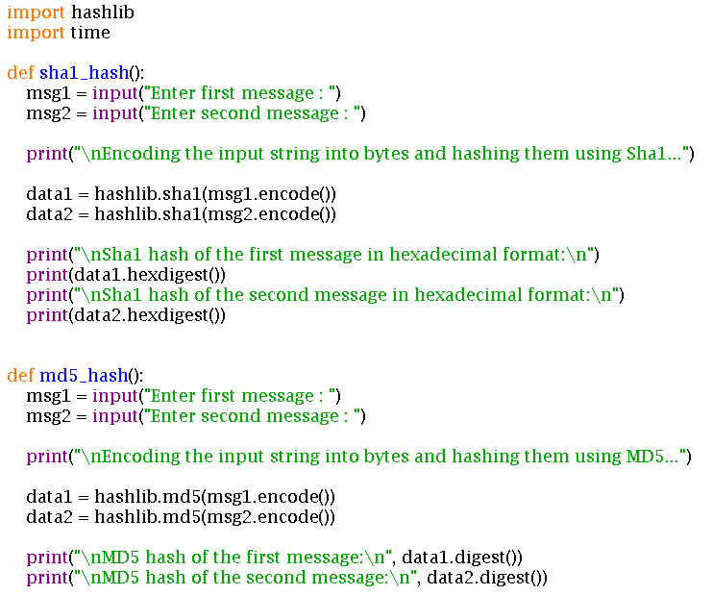
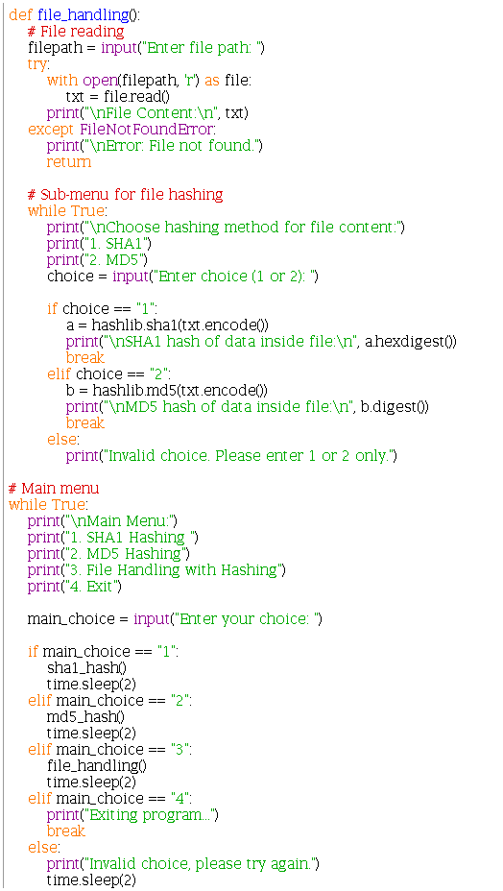

Output:
